PROFOUND WALK WITH GOD MINISTRY
CHILDREN SPIRITUAL GROWTH

The Holy God
Memorize it! “But as he which hath called you is holy, so be ye holy …….”
1 Peter 1:15.
Bible verses: 1 John 3:8-9, 1 Peter 1:16.
Talk
Children are like their parents. They inherit (get from their parents) things that reflect the image of their parents. Maybe people have told you that “you have your dad’s face” or maybe “you talk just like your mom,” Parents can be “seen” somehow in their children. God is holy, and he is our father. His children should bear the “family resemblance”- they should be holy, like their father is holy. 1 Peter 1:16.
To be holy means to be completely separate (set apart) from sin. God works in Christians to set them apart from their sinful selves and from the sinful world.
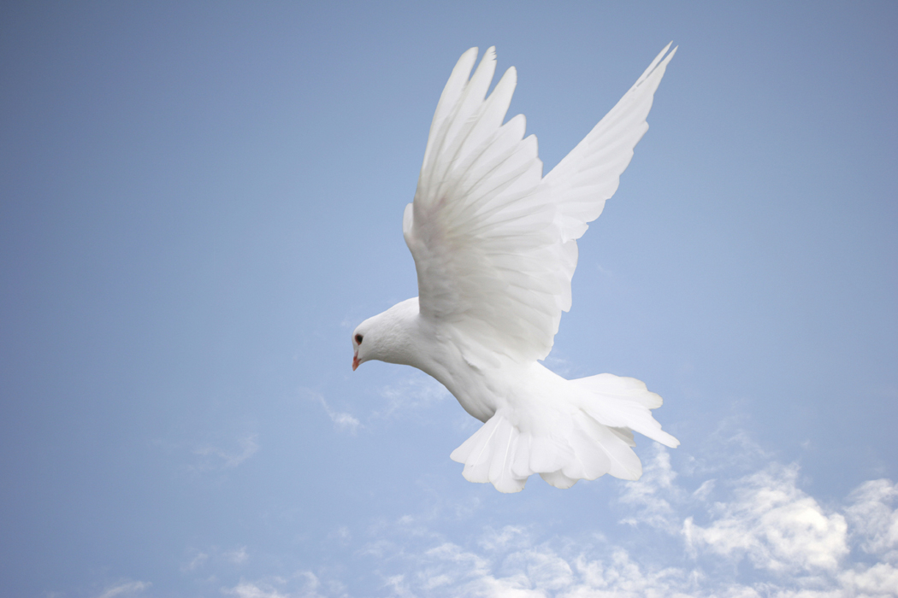

Dig
God commands us to be holy. God shows us that He is both holy and good. To be holy in heart and mind is to have our whole selves devoted to the righteous Christ and not to sin. 1John 3:7.
Heart Gauge
What does it mean to be holy in heart and mind?
Measure Your Knowledge
In the next few sentences, please circle the letter of the one that is true:
- Christian should not care to live holy live.
- To be holy means to be bad.
- Every child of God is supposed to be holy as He is holy.

Work to do
Look up the following verse and write something about holy God.
1 Peter 1:16 __________________________________________
__________________________________________
1 Peter 1: 15 _______________________________________________
_______________________________________________

