PROFOUND WALK WITH GOD MINISTRY
CHILDREN SPIRITUAL GROWTH

Victory In Jesus Christ
Memorize it! That at the name of Jesus every kneel should bow, of things in heaven, and things in earth, and things under the earth” Philippians 2: 10
Bible verses: Philippians 2:5-11, John 1:12
Talk
If Christ had not risen from the dead, then that would mean that sin and death got victory over Him. But since Jesus Christ beat sin and death by living sinlesssly and by coming back to life, we can know that He has won the ultimate victory. He also gave those that believe in Him the victory and the power to become the children of God.
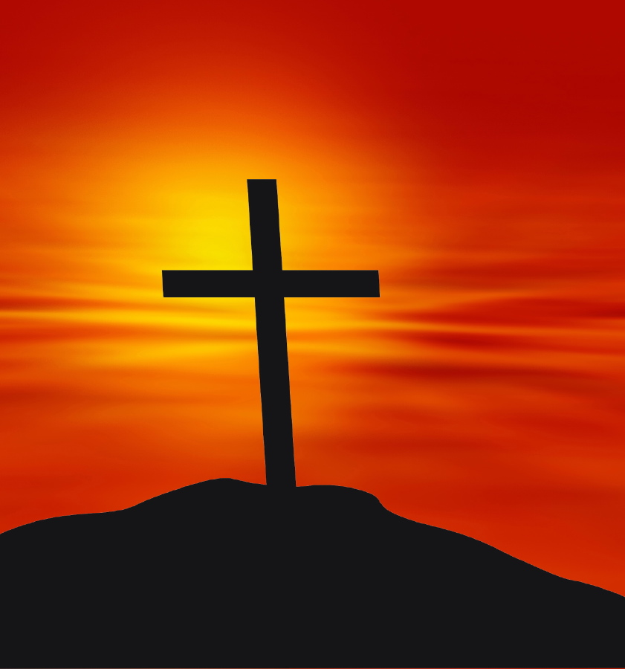
Dig
Every true believer has the power to overcome through Jesus Christ our Lord. He who raised Jesus Christ from the dead will also give life to your mortal bodies through His Spirit who dwells in you.
Heart Gauge
How do you feel about the resurrection when you think of it as the main way Jesus proved He was more powerful than sin and sin’s penalty of death?
Measure Your Knowledge
What hope do Christians have for victory over sin and for rescue from eternal death?
Work to do
Write two sentences of what you understand in Philippians 2:10
…………………………………………………………………………………………………..
…………………………………………………………………………………………………..
…………………………………………………………………………………………………..
…………………………………………………………………………………………………...
……………………………………………………………………………………………………
…………………………………………………………………………………………………..

